BMW E60 CiC Retrofit
DISCLAIMER: EVERYTHING DESCRIBED HERE IS RELEVANT TO A BMW E60 FROM 2004 WITH CCC, IF YOU FOLLOW THIS GUIDE YOU DO SO AT YOUR OWN RISK!! WHEN IN DOUBT ASK THE PEOPLE ON THE FORUMS OR PATRYK.
After reading about the CiC retrofit on the E60.net forums I decided to retrofit it.
Before you buy this set, be sure to make up your mind if you want to retrofit the Combox later or not, because if you change your mind and decide to retrofit the Combox afterwards you will have to send the CiC back to Patryk for manual coding. This cannot be done remotely. (Thanks to bruce_miranda for pointing that out)
I bought a set from Patryk (Patrys on the forum) with the navigation maps OEM activated. This set contained these parts:
- CiC (the computer)
- CiD (HD Screen)
- CiC HD Screen cable (this connects the CiC to the CiD)
- USB Port cable
- USB Port (goes into the glove box)
- CiC Center trim (CCC had a CD and a DVD slot, CiC only has the DVD slot)
- CiD power connector (flat blue connector that uses wires from the old connector)
- New iDrive controller + controller trim to retrofit it into the old wooden panel (optional)
Required items:
- Set of regular size screwdrivers (flat, Philips head, Torx)
- Precision screwdrivers (standard set)
- Set of sockets + wrench (if you want to change to the new iDrive controller)
- DCAN Interface Cable (suitable for INPA / EDIABAS)
- BMW complete update of ECU and other modules before installing
- Wire taps
- Shrink tubing
This retrofit can be done in 20 minutes if you have ADHD, a photographic memory, are on the verge of a caffeine overdose and have retrofitted this at least 10 times. Normal people can do this in about 4 hours.
I must say that everything went very smooth with Patryk, the package was delivered very fast and if I needed to know something he’s fast to respond. The parts he sold me were all in perfect condition and thanks to the forums and the people there I’ve been able to do this sweet retrofit without too much hassle.
I have taken the liberty of using photos of the forum members’ retrofit because I did mine at night :p. Wherever possible I mentioned the name of the photo owner.
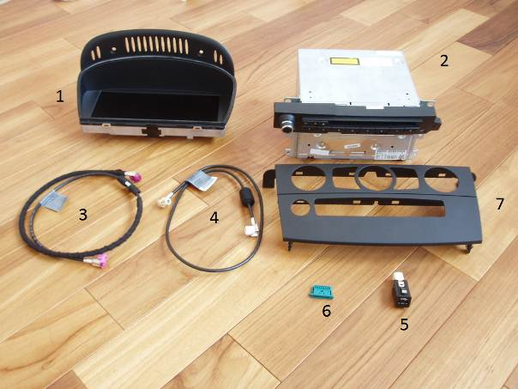
Here you can see the BASIC set you need for the retrofit.
- CiD HD Screen
- CiC computer
- CiC HD screen cable
- USB Port cable
- USB Port
- CiD power connector
- Center trim
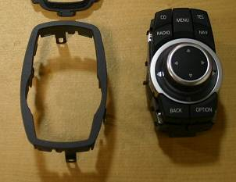
OPTIONAL: This is the new version iDrive controller with preset buttons. When you order with Patryk he will also supply the bezel to make it fit nicely in the E60.
If you order this, I suggest you install this first because it’s the most time consuming part to install because you have to cut into the trim of the center console and the center console.
Pclausen has documented how to remove the center console here: http://forums.5series.net/topic/99495-cic-retrofit-installation-log/page__view__findpost__p__1207895
The only things missing in that DIY was the fact that you need to disconnect the lighter socket from its harness and that there is a small screw that holds the eject box wiring harness plug to the bottom of the center console in the back that needs to be removed. This is also best done with the trim on the PDC button panel off, makes it easier to lift the center console without scratching it. (Thanks to bruce_miranda for pointing this out)
Adjusting the trim panel for this has been documented on the m5boad.com forums by “stunt”: http://www.m5board.com/vbulletin/e60-m5-e61-m5-touring-discussion/160673-2010-cic-install-2006-m5-pictorial-12.html#post1966366
The new controller uses only 1 connector whereas the old one used 2 (1 for the menu/voice control button and 1 for the controller itself). You will need the small connector from the menu/voice control button. Remove all the wires from the small connector and move the following pins from the large 8 pin connector to the small one:
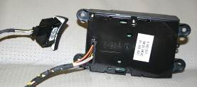
Big connector pin (orange arrow) | Small connector pin socket (blue arrow) | Function
1 | 1 | 12V
2 | 2 | GND
4 | 3 | CAN_H
5 | 4 | CAN_L

The remaining wires are no longer used and can be insulated and tied back.
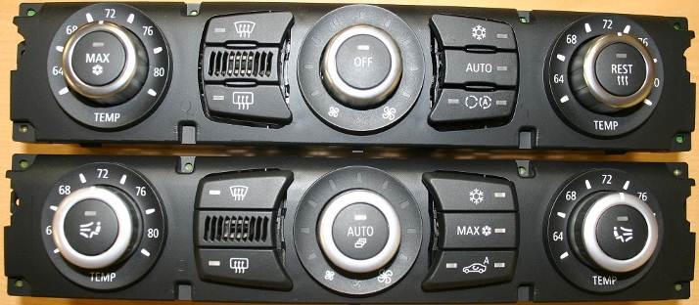
Old climate controls vs. new climate controls (temperature in Fahrenheit).
OPTIONAL: If you decide to retrofit the new climate controls you will have to make some adjustments to the wiring to avoid problems with the compressor and engine radiator fan. Otherwise it’s plug & play.
Keeping the old climate control panel will also work but there are small gaps where the 5 buttons and the temperature sensor is located.
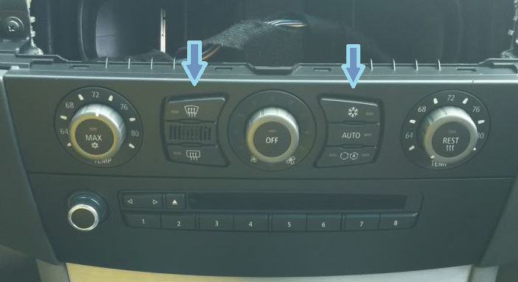
The wiring changes are minimal and are described here by pclausen: http://forums.5series.net/topic/99495-cic-retrofit-installation-log/page__view__findpost__p__1244430

Overview of procedure for the basic kit:
- Disconnect battery
- Remove the dashboard trim (with the ventilation grills in it)
- Remove trim from A/C panel & CCC & controls block on bottom (seat heating, DSC, PDC, …)
  - Remove bottom trim panel from top trim and replace top trim panel by the one you got from Patryk
- Disconnect & Remove CCC (you can also disconnect the A/C controls if they’re in the way)
- Remove old display
- Route the CiC => CiD cable from the old CCC location to where the new HD Screen will come
- Remove pins from old screen power connector and insert into new screen power connector (flat blue connector)
- Tie back the old screen cable CCC (no longer required).
- Route the USB cable from the old CCC location to the glove box compartment.
- In case that you have the HiFi sound system (BMW option code 0676) you will have to make changes to the Quadralock connector (the big connector block that goes into the CCC/CiC) to get some base from the speakers. (Woofer fix)
- Reassemble everything
- Coding
Detailed procedure for the basic kit:
Removing the dashboard trim: (Photo’s courtesy of Lomag on E60.net forum).
Insert a flat screwdriver under the door lock button and lift the button out | Disconnect when removed.
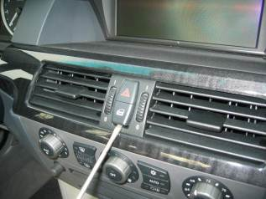 | 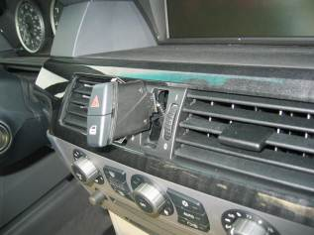

Open the passenger door and insert a flat tool (screwdriver or hard piece of plastic, just be careful not to scratch anything) under the side to lift the panel a bit. Do this along the whole length of the trim carefully until it is loose so you can pull out the trim along with the vents that are attached to the trim. | Here you can see the white clips that hold the trim in place. If they are still attached to the trim, pull them off and replace them to the dash and turn them a bit so they look like diamond shapes (you will feel they will be fixed more this way)
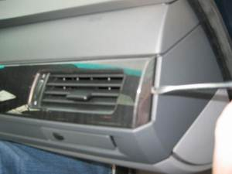 | 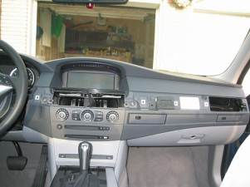
Be gentle when pulling out/inserting the trim with the vents because the vents are lined with foam and can be easily torn.
Removing the trim from the A/C panel, CCC & control block on bottom:
Unscrew the 2 Philips head screws indicated by the red arrows
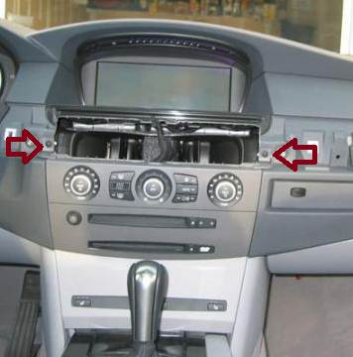
Now you can pull out the trim out a bit on the top, it isn’t attached to anything but in the middle and bottom part there are clips (white arrows indicate approximate location) that have to be snapped loose. These can be a bit hard to unsnap, I had to wedge use a flat blade screwdriver between the panel en the trim on the bottom clips. It is possible some of these clips are not pulled out with the trim panel, just pull them from the dashboard and attach them back to the trim.
When the panel is loosened you can push the A/C controls out of the panel and the bottom button for ASC/DSC/Seat heating too. They are usually clipped onto the panel backside. You can disconnect the A/C controls as well as the bottom button row to make it easier to remove.
Replacing upper part of trim with new trim for CiC:
Old upper & lower trim still attached | Bottom trim removed
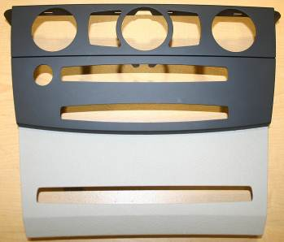 | 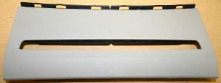
When separating the 2 trim pieces you will see on the back it is attached together with tabs, when separating I broke several of those tabs. In the new top trim panel the tabs are no longer used anyway.
Remove CCC and disconnect all cables from the CCC
The CCC is screwed in with 4 Philips head screws as shown by the red arrows:
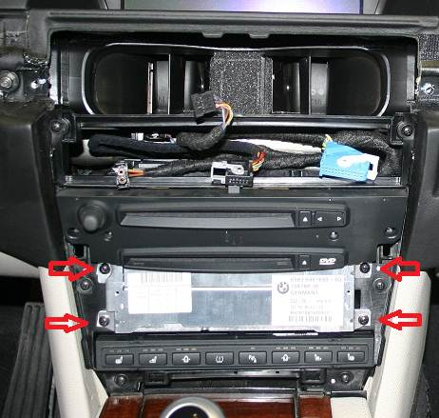
Remove all 4 screws and pull back the CCC until you can see the cables and disconnect them all from the CCC.
Remove old screen from dashboard:
This is straightforward; it is affixed with 2 screws on the top of the screen on the black plastic part. You will need the precision screwdrivers to unscrew them. Gently tilt & lift the screen out from the dashboard and disconnect it.
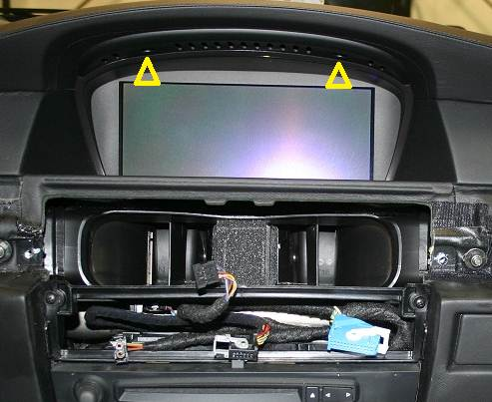

Route CiC => CiD cable from the location where the CCC used to be to where the monitor is located
This is the cable with the pink connector. Just start from where the CCC was located and see if you can route the cable in the same manner as the old screen cable is routed to the screen.

Remove pins from old screen power connector and insert into new screen connector (flat blue connector)
You can remove the wire from the old connector by using a precision flat screwdriver to depress the small dimple in the old plug. When the wire is removed from the old plug, just insert it into the new connector according to the following pin designation:
Connector pin numbers are printed on the bottom of the blue connector; 1 is the first pin and 8 is the last pin.
Move the following wires to these pins in the blue connector:
- Red/purple => pin 1
- Brown/black => pin 3
- Black => pin 5
- Yellow => pin 6
Old power connector | New power connector with cables from old connector
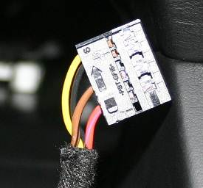 | 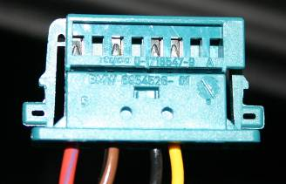

Route the USB cable from the old CCC location to the glove box compartment.
Again from the old CCC location route the USB cable to the glove box in a location you prefer. When the USB cable is routed into the glove box you can connect the USB port. If you want you can place the connector in the location where the glove box flashlight is fitted for a clean look.
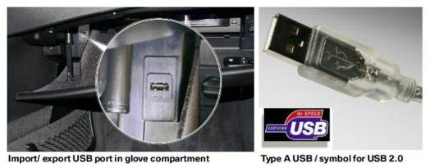
In case that you have the HiFi sound system (BMW option code 0676) you will have to make changes to the quadralock connector (the big connector block that goes into the CCC/CiC) to get some base from the speakers. (Woofer fix)
Since the CiC the outputs that interface with the CiC and amplifier have changed. This is a fix suggested by Patryk, Technic, GeorgieB and pclausen.
This is the Quadralock connector:
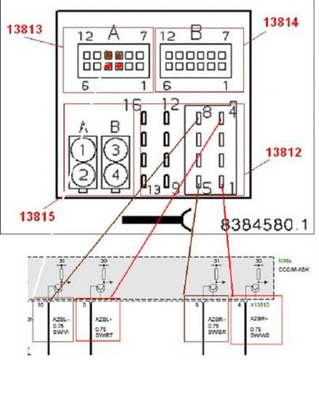
What you need to do is remove pins 3, 4, 9 and 10 from the 13813 block. Leave the pins in 13812 in their socket! Now using for example tap connectors you connect the loose wires that were in block 13813 to the wires in socket 13812 in the following order:
13813 (removed pins) | 13812 (connect to these wires, DO NOT REMOVE PINS!!)
Pin 3 | Pin 4
Pin 4 | Pin 1
Pin 9 | Pin 5
Pin 10 | Pin 8

See here for more information: http://forums.5series.net/topic/99495-cic-retrofit-installation-log/page__view__findpost__p__1234488
Reassemble everything:
First make sure that any electrical connections you have altered have been securely shielded from exposure to other elements to avoid short circuits! Use shrink tubing or electrical tape when needed.
- Plug in the following:
  - power connector in the screen (blue flat connector)
  - The pink connector in the screen
  - Quadralock in CiC
  - USB Cable in CiC
  - GPS Cable in CiC
  - AM/FM Tuner antenna in CiC
  - Pink/Violet connector in CiC
  - DAB antenna (if available)
- Reconnect battery
- Check if CiC screen is operational and that CiC is responding to commands from iDrive controller/Steering wheel.
- Disconnect battery again
- Screw in HD Screen using same screws with the precision screwdrivers
- Screw CiC back in using the 4 screws that were used for the CCC
- Attach bottom controls of center console (DSC, seat heating,…) back to trim (if you removed the cables don’t forget to reconnect them)
- Attach bottom trim of center console
- Attach A/C controls to new top trim (don’t forget to reconnect the controls if you disconnected them.
- Attach top trim of center console and screw it back in on the top with the 2 screws
- Align dashboard trim with white plugs (turned in diamond shape), route door lock/hazard lights button wiring thru hole and push the trim back into place carefully watching the foam surrounding the vents.
- Attach door lock/hazard lights button to cable and push into trim.
- Reconnect battery.
Coding:
This is where Patryk does the finalization of the CiC installation by recoding any issues that have not been pre-coded by him. If possible ask to borrow DCAN cable from Patryk, even better is buying one from him in case you need an update later. That way he doesn’t have to resend it each time. Make sure you have a stable internet connection and laptop with XP, Vista or 7, 32bit version. Actual coding takes about 20mins. (Perhaps more if you need a big update) once he’s connected to the car.
REMARKS:
Do not get rid of your old CCC because when your dealer has to do some major work which requires programming you will have to swap out the CiC for the CCC otherwise the dealer will not be able to code it.
Do not expect to receive a brand spanking new CiC retrofit package, these are salvaged units from probably demo cars but are in perfect working condition without any usage marks.
Coding does not take long as I said before, but to be on the safe side make sure to have your battery fully charged and if possible connected to a battery maintainer/charger should coding take longer than usual.
The woofer fix for cars with HiFi option 676 is not ideal but it gives a bit more base, best would be to buy a good amp. Check with Technik on the forum he’s the man for sound in the BMW.
Since I took the OEM route instead of the alternative “hacked” pcb way, I paid a bit more but with the certainty that it will work without any glitches.
If you have voice control than you will have to buy an FSC code to make it work with the CiC, unless you take the “hacked” way.
I received the CiC with preloaded navigation maps so in my case I didn’t have to upload the 3 DVD’s.
Climate control works fine, except that I can’t adjust the airflow volume to the feet, face or windscreen. Maybe it still needs to be programmed or I will have to retrofit the new A/C panel.

TIME TO GO PLAY WITH THE IDRIVE NOW, HOPE THIS HELPS OUT A BIT GUYS.

Sven (aka brosken on E60.NET)

Sources:
E60.NET, M5BOARD.COM , E90POST.COM, BMWBLOG.COM
http://forums.5series.net/topic/99495-cic-retrofit-installation-log/
Special thanks for the info and pictures to: Patryk, nelson29, Georgieb, pclausen, technic, stunt, Lomag, bruce_miranda and everybody else I forgot to mention. ;)

